APP

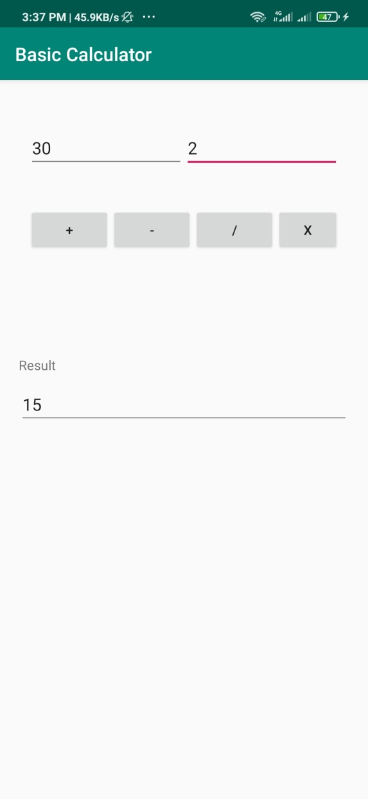

**Addition**

num1 = (EditText) findViewById(R.id.num1);

num2 = (EditText) findViewById(R.id.num2);

add = (Button) findViewById(R.id.add);

sub = (Button) findViewById(R.id.sub);

mul = (Button) findViewById(R.id.mul);

div = (Button) findViewById(R.id.div);

res = (TextView) findViewById(R.id.result);

outError = (TextView) findViewById(R.id.outErr);

add.setOnClickListener(new View.OnClickListener() {

@Override

public void onClick(View v) {

int n1 = Integer.parseInt(num1.getText().toString());

int n2 = Integer.parseInt(num2.getText().toString());

int sum = n1 + n2;

res.setText(String.valueOf(sum));

num1.setText("");

num2.setText("");

}

});

**Subtraction**

sub.setOnClickListener(new View.OnClickListener() {

@Override

public void onClick(View v) {

int n1 = Integer.parseInt(num1.getText().toString());

int n2 = Integer.parseInt(num2.getText().toString());

int total = n1 - n2;

res.setText(String.valueOf(total));

num1.setText("");

num2.setText("");

}

});

**Multiplication**

mul.setOnClickListener(new View.OnClickListener() {

@Override

public void onClick(View v) {

int n1 = Integer.parseInt(num1.getText().toString());

int n2 = Integer.parseInt(num2.getText().toString());

int total = n1 * n2;

res.setText(String.valueOf(total));

num1.setText("");

num2.setText("");

}

});

**Division**

div.setOnClickListener(new View.OnClickListener() {

@Override

public void onClick(View v) {

int n1 = Integer.parseInt(num1.getText().toString());

int n2 = Integer.parseInt(num2.getText().toString());

if(n2 == 0 || n1 == 0){

Toast.makeText(MainActivity.this, "The divisor must be greater than zero.", Toast.LENGTH_SHORT).show();

num1.setText("");

num2.setText("");

}else {

int total = n1 / n2;

res.setText(String.valueOf(total));

num1.setText("");

num2.setText("");

}

}

});